Kaley Lavery
CS-360 Mobile Architecture and Programming
Professor Krauss
14 December 2025
CS-360 Module Seven Assignment: Project Three
This submission includes the completed Daily Weight Tracking mobile application, developed in Android Studio using Kotlin and Jetpack Compose. The application meets all Project Three requirements by implementing user authentication, a persistent SQLite database, full CRUD functionality, and optional SMS permissions.
The following artifacts are included:
- ZIP File:
A compressed Android Studio project folder containing all source code, database logic, UI components, and configuration files required to build and run the application.
- Screenshots :
Visual evidence demonstrating successful application functionality, including:
- Account creation
- User login validation
- Adding a daily weight entry
- Updating an existing weight entry
- Deleting a weight entry
- Viewing populated weight history
- SMS permission request screen
Application Functionality Summary
Login & Account Creation
- Users can create a new account with a username and password.
- Existing users can log in and receive confirmation of successful authentication.
- Credentials are stored persistently in a SQLite database.
Daily Weight Tracking (CRUD Operations
- Users can add daily weight entries with a date.
- Existing entries can be updated or deleted.
- All stored entries are displayed in a scrollable data grid, demonstrating full Create, Read, Update, and Delete functionality.
SMS Permissions
- The application includes an SMS Notifications screen that explains the optional nature of SMS alerts.
- Users can request SMS permission through a clearly labeled button.
- The app continues to function normally regardless of whether permission is granted or denied, as required.
Testing and Validation
The application was tested using the Android Emulator (Medium Phone API 36.1).
All core features function as intended, and the application builds and runs without errors.
Conclusion
This project demonstrates a fully functional mobile application that follows Android development best practices, including modular code structure, state management with Compose, database persistence, and permission handling. The application is ready for future enhancements such as automated SMS alerts tied to weight milestones.

- Account Created:
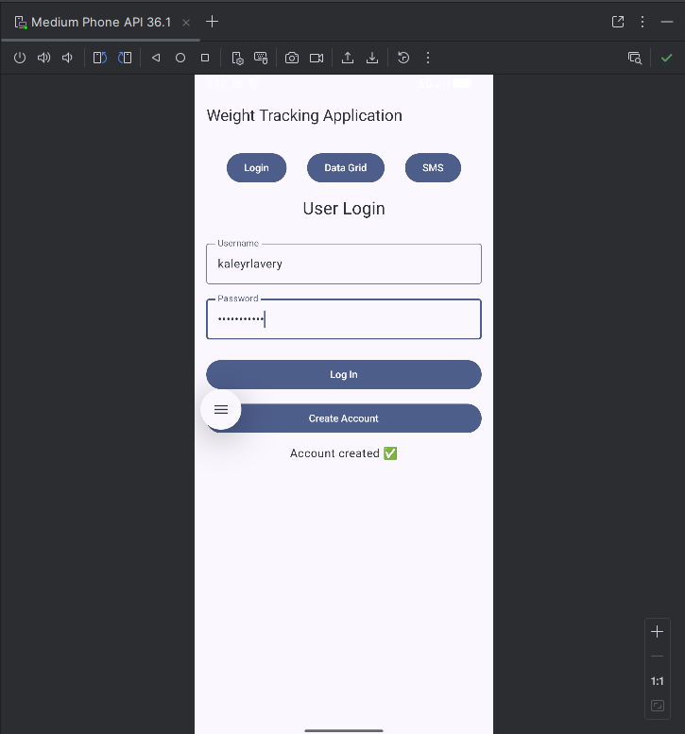

- Log In Successful:
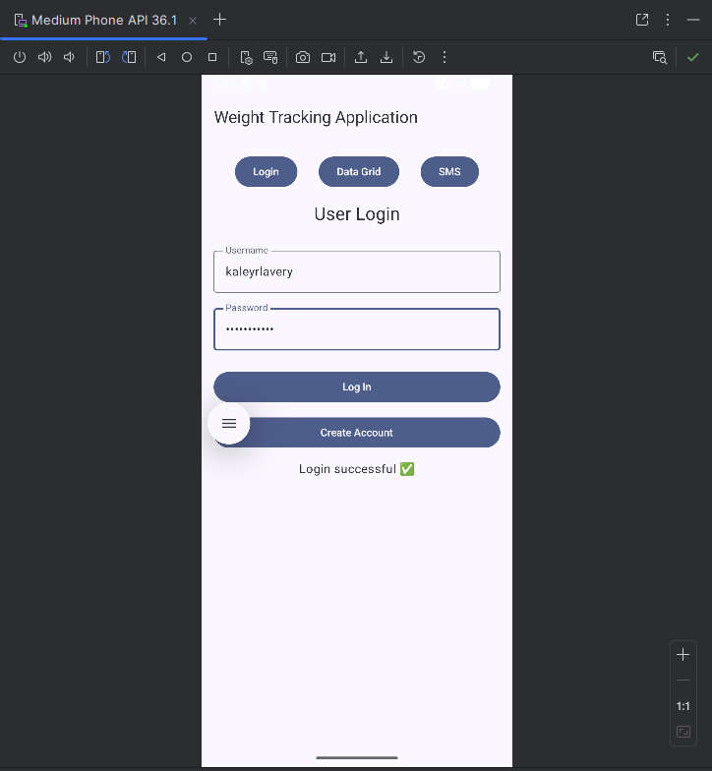

- Weight Added:
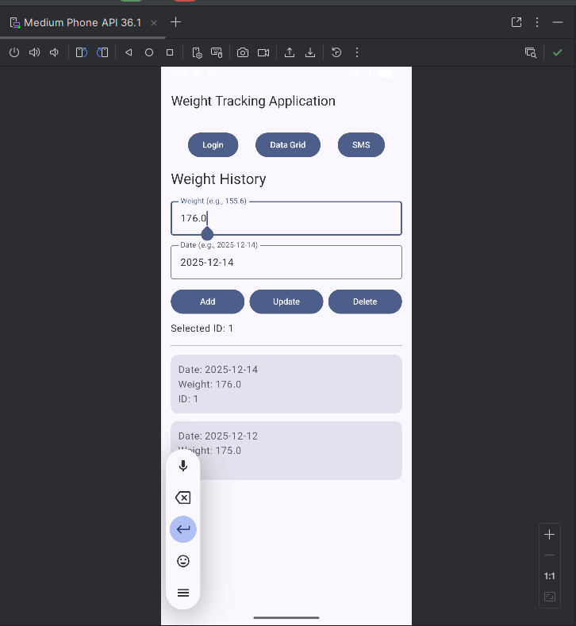

- Weight Updated:
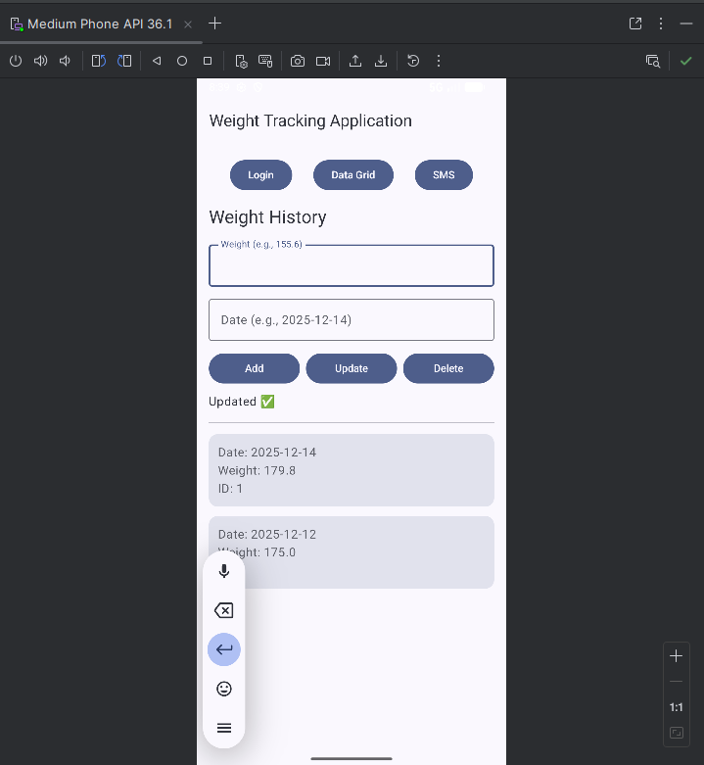

- Weight Deleted:
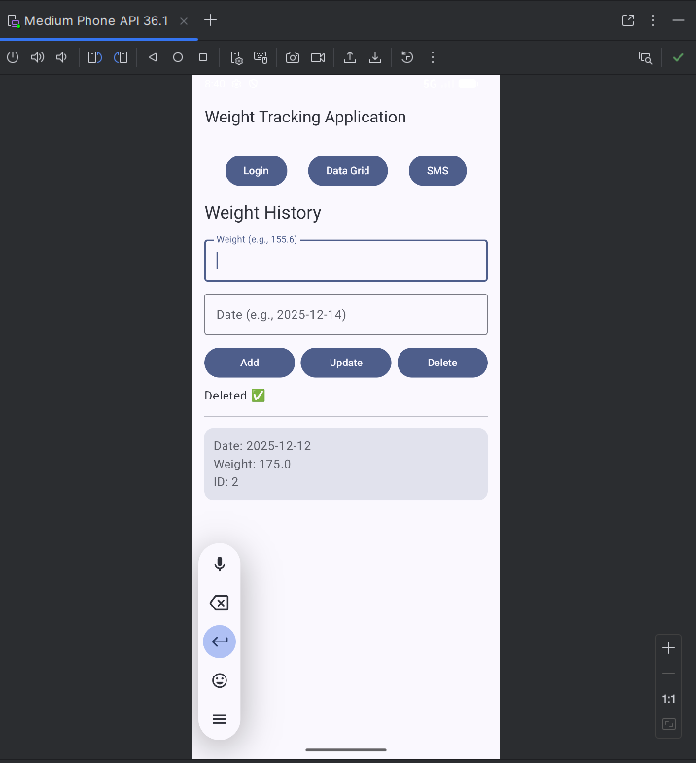

- Populated Weight History:
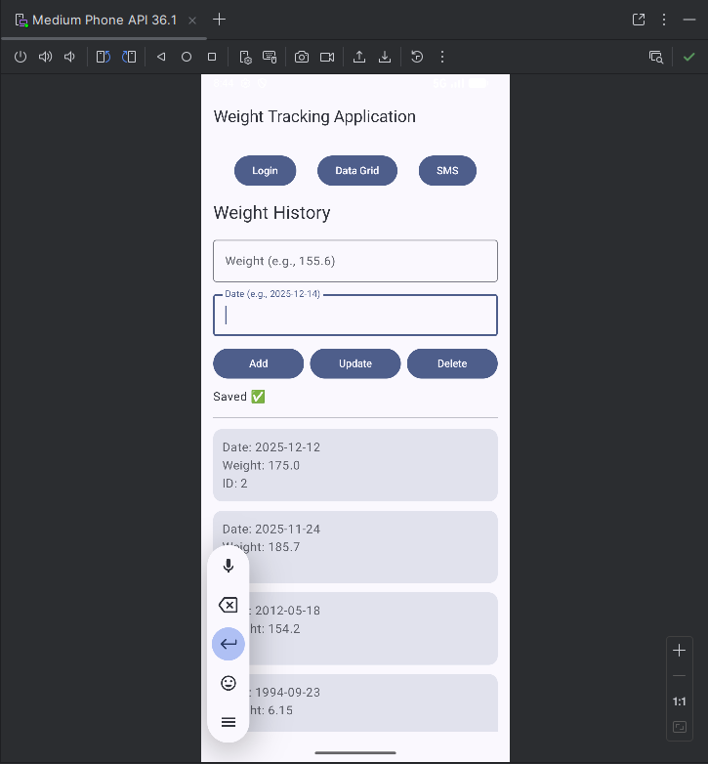

- Permissions Requests Button:
